International University, HCMC National University

School of Computer Science and Engineering

**PROJECT REPORT**

### Algorithms & Data Structures

**Game: MINE SWEEPER**

|  |  |  |  |
| --- | --- | --- | --- |
| **No.** | **Full Name** | **Student ID** | **Evaluation (%)** |
| 1 | Nguyễn Duy Phúc | ITDSIU21030 | 25% |
| 2 | Vũ Vỹ Khang | ITDSIU21090 | 25% |
| 3 | Phan Quốc Anh | ITDSIU21001 | 25% |
| 4 | Nguyễn Quốc Huy | ITDSIU21067 | 25% |

COURSE: Algorithms & Data Structures_S2_2022-23_G01

INSTRUCTOR: Teacher Lam (Lab), Teacher Tung (Theory)

**TABLE OF CONTENTS**

[**1. Introduction**](https://docs.google.com/document/d/1wI0ZiNaUhDhZFthKvX-7Ra6g1SQUBww7zeE0nm_uC6A/edit?fbclid=IwAR2azTBw9I4iQC3qVPBx_S2nxxTXoPB0Z_30rcQslemIDJA_LB-P-rmMIU8#heading=h.qf23fpoxtki)

[**2. About**](https://docs.google.com/document/d/1wI0ZiNaUhDhZFthKvX-7Ra6g1SQUBww7zeE0nm_uC6A/edit?fbclid=IwAR2azTBw9I4iQC3qVPBx_S2nxxTXoPB0Z_30rcQslemIDJA_LB-P-rmMIU8#heading=h.h3jg56i2tg2l) **Game**

1. Ideas

2. Rule

**3. Code and Algorithms**

**4. Conclusion**

[**5. Reference list**](https://docs.google.com/document/d/1wI0ZiNaUhDhZFthKvX-7Ra6g1SQUBww7zeE0nm_uC6A/edit?fbclid=IwAR2azTBw9I4iQC3qVPBx_S2nxxTXoPB0Z_30rcQslemIDJA_LB-P-rmMIU8#heading=h.xb2otx80qyxq)

--------------------------------------------------------------------------------

**1.Introduction:**

Minesweeper is a classic computer game that has been enjoyed by millions of players around the world for decades. The game is simple yet challenging, requiring players to use strategy and deduction to clear a minefield without detonating any hidden mines. In this report, we will explore the history of Minesweeper, its basic rules and gameplay mechanics, and the strategies that players can use to improve their performance.

Whether you are a seasoned Minesweeper player or a newcomer to the game, this report will provide valuable insights and information about one of the most beloved computer games of all time.

[**2. Ideas & Algorithms**](https://docs.google.com/document/d/1wI0ZiNaUhDhZFthKvX-7Ra6g1SQUBww7zeE0nm_uC6A/edit?fbclid=IwAR2azTBw9I4iQC3qVPBx_S2nxxTXoPB0Z_30rcQslemIDJA_LB-P-rmMIU8#heading=h.h3jg56i2tg2l)

1. Ideas:

Minesweeper is a game that involves a map, bombs, flags, and other features that make it both challenging and exciting. The map is a grid of squares that can vary in size, and some of these squares contain hidden bombs. The objective of the game is to uncover all the squares that do not contain bombs while avoiding the ones that do. To do this, players must use logic and deduction to determine which squares are safe to uncover and which ones are not.

In addition to uncovering squares, players can also mark squares that they suspect contain bombs by placing a flag on them. This helps players keep track of which squares they believe are dangerous and avoid them. However, players must be careful not to use too many flags, as they have a limited number available.

To make the game even more challenging, there are different difficulty levels that players can choose from. These levels determine the size of the map and the number of bombs hidden within it. The higher the difficulty level, the more challenging the game becomes.

To help players navigate the game, there are also additional features such as undo, save game, and choose difficulty. The undo feature allows players to undo their last move if they make a mistake, while the save game feature allows players to save their progress and come back to the game later. The choose difficulty feature allows players to select the level of difficulty that they feel comfortable with.

2. Rule:

Players must clear a minefield without detonating any hidden mines. The game is played on a grid of **squares**, and the objective is to uncover all the squares that do not contain mines while avoiding the ones that do. To play, the player clicks on a square to uncover it. If the square contains a mine, the game is over, and the player loses. If the square does not contain a mine, a number is displayed indicating how many mines are adjacent to that square. Using the numbers as clues, the player can deduce which squares are safe to uncover and which ones contain mines. The player can mark squares that they suspect contain mines by right-clicking on them with the mouse. The game is won when all the squares that do not contain mines have been uncovered. The game can be customized with different difficulty levels.

**3. Code and Algorithms**

3.1 Create Board

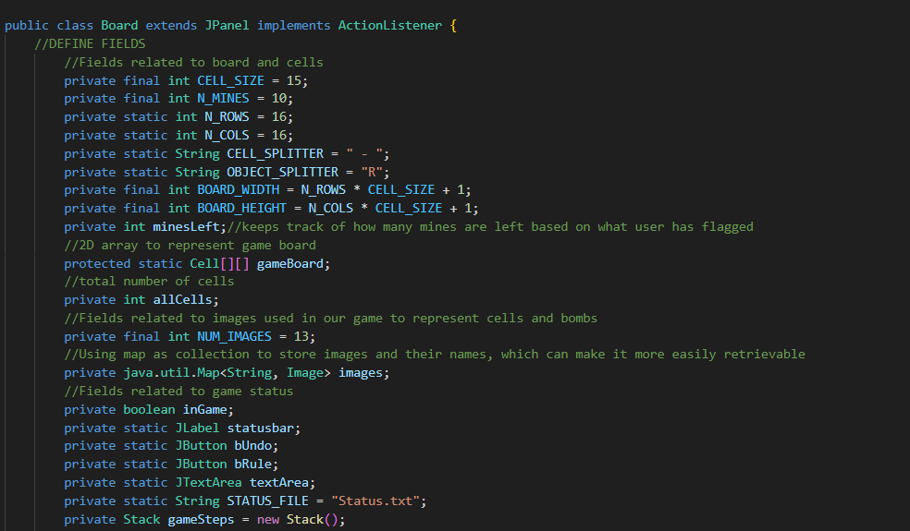

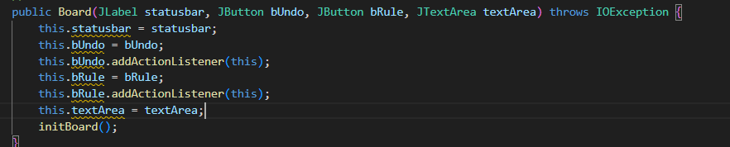

3.2 Create Mines

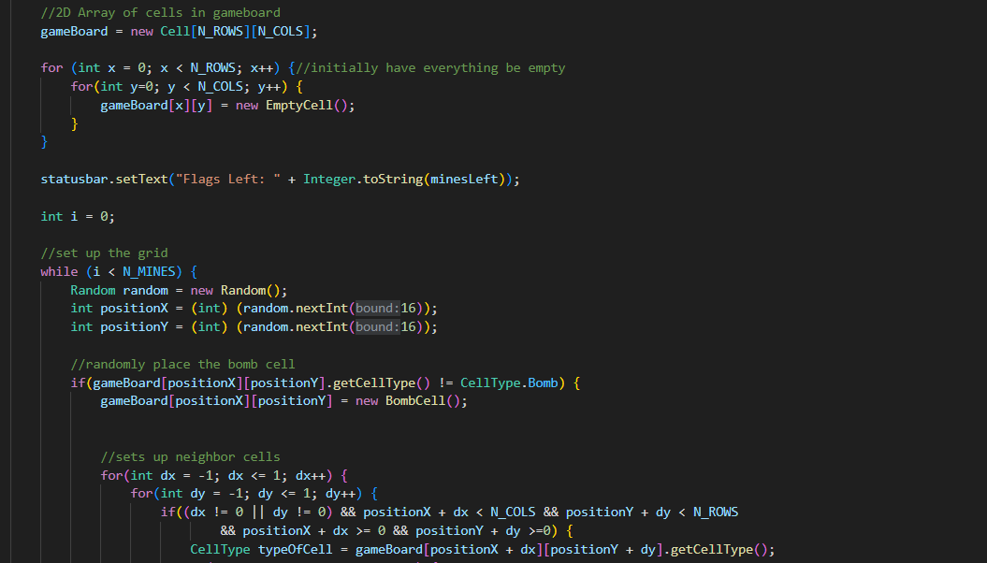

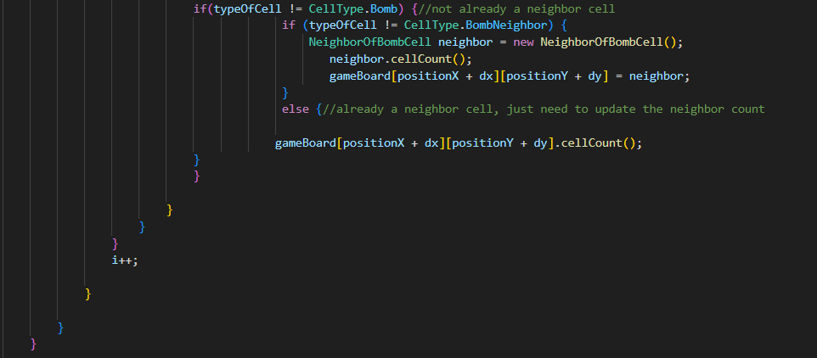

3.3 Add image into Board

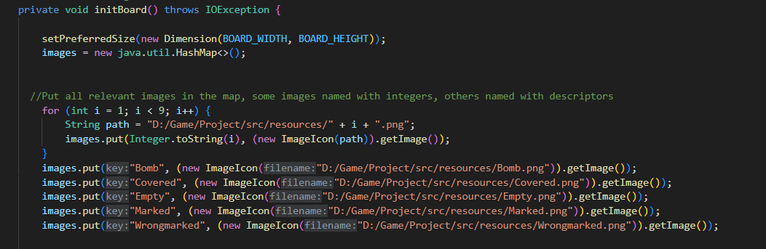

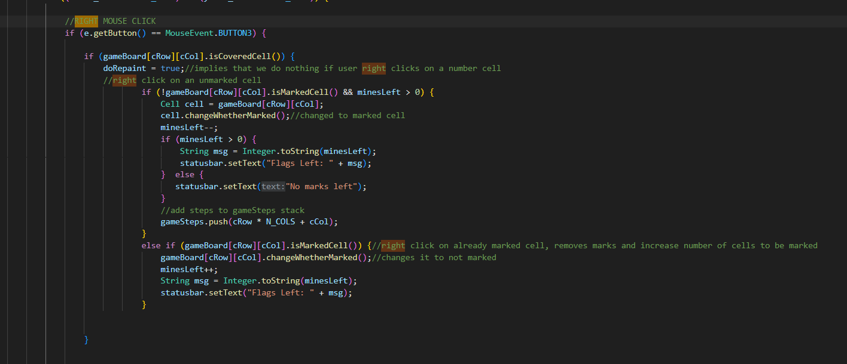3.4 Create Mark with right clicked on mouse

3.5 Left mouse click and repaint when click on boom

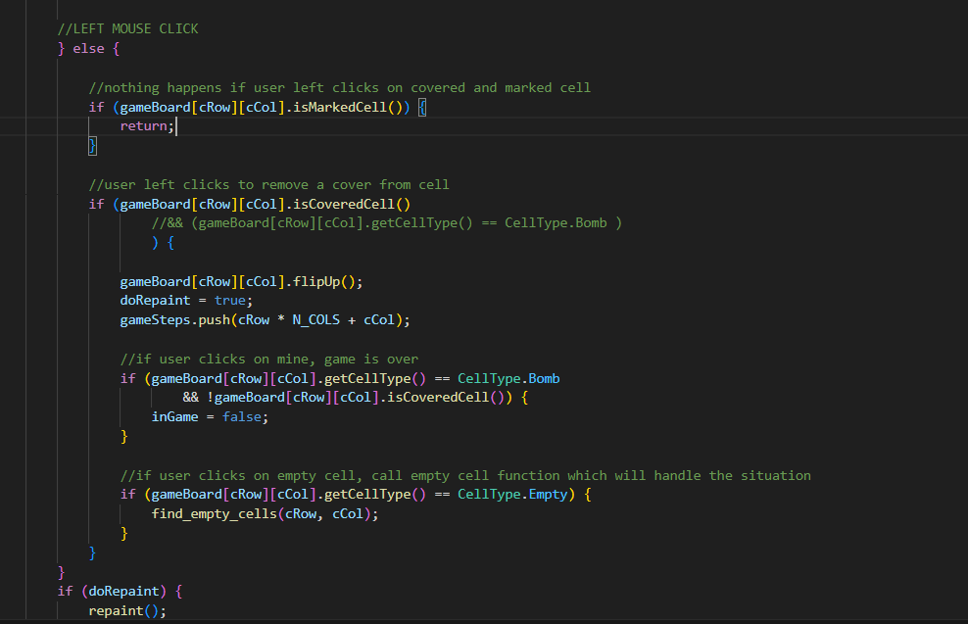

3.6 Create button Rules to notice Rules with player

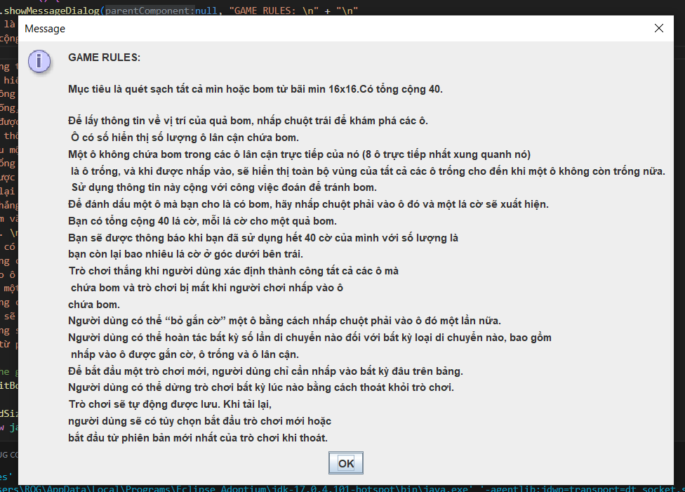

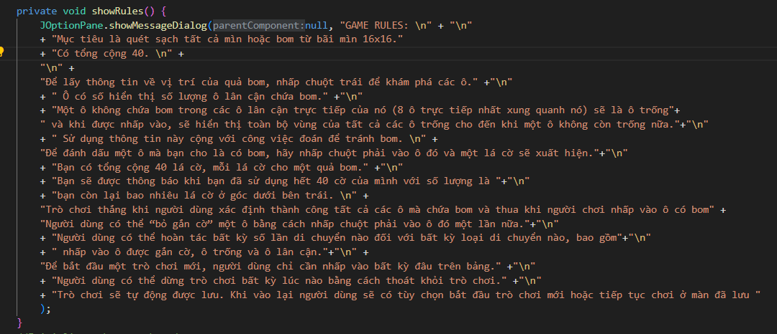

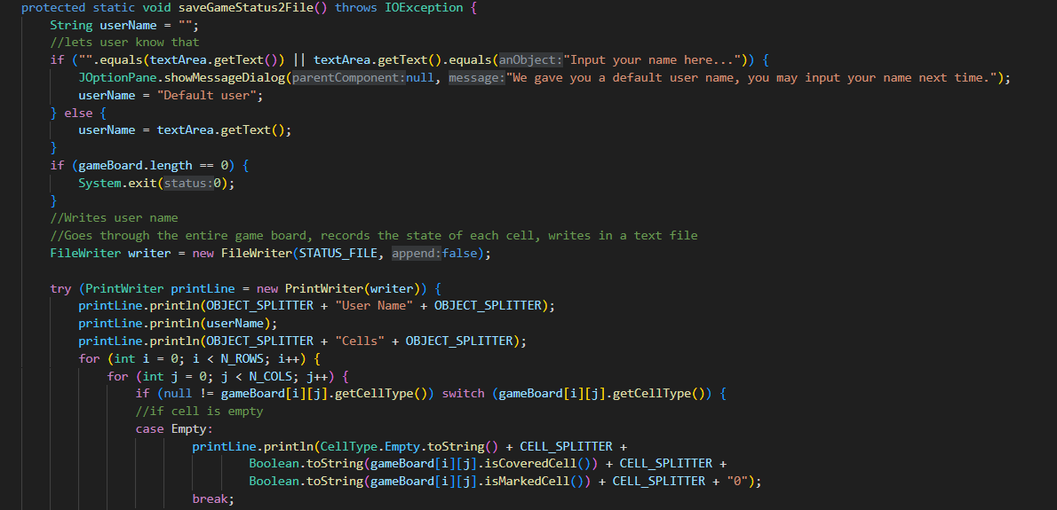3.7 Define username and method saving game

**Describe Algorithm use in project:**

By default, the cells are closed, unexploded and unmarked.

When the new table is initialized, we perform 2 steps. Step 1, land mines in random cells. Step 2, browse each cell of the board and count the number of mines around that cell. If that cell already has mines, ignore it, otherwise write the count in the cell's mine count property (counting with 0 is still recorded).

When the left click event occurs, the open property is set to true, and the surrounding mines value is checked. If the value is 0, then use recursion to open the surrounding cells. The recursion will stop when that value is not 0. This is how when we click on an empty cell, a bunch of unimportant cells will open.

**4. Conclusion:**

After dealing with the project, we remember and take note about how recursion work, know how to implement UI with java swing, understand how to convert img with code. But we couldn't complete what we were supposed to add functionality like choosing the difficulty of the levels, creating more characters to make the game more vivid. We will try to implement that after we finish this presentation.

**5. References**

<https://www.youtube.com/watch?v=jV1x6il0AzA&list=PLlD_ilI9JDbBVYP5uQUII81Q3w_pxAKhB>

<https://github.com/janbodnar/Java-Minesweeper-Game>

<https://github.com/luckytoilet/MSolver>

<https://zetcode.com/javagames/minesweeper/>

https://codereview.stackexchange.com/questions/172338/beginner-java-minesweeper-game